CO2-AT3_Questions-Slot-C

Register No: 192425259
Student: G Uday Siva Sai
Assigned Question:
Q7. Debugging Insertion Sort Code
The following Insertion Sort code fails to correctly place elements in sorted order. Identify errors in shifting logic and loop conditions. Explain why incorrect insertion occurs. Debug the algorithm step-by-step to ensure correct functionality. Optimize the code for better readability. Analyze the time complexity. Rewrite the corrected version with proper structure and comments.
def insertion_sort(arr):
for i in range(1, len(arr)):
key = arr[i]
j = i - 1
while j > 0 and arr[j] > key:
arr[j+1] = arr[j]
j -= 1
arr[j] = key
return arr
Solution :
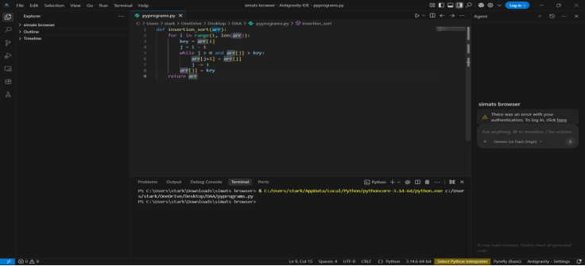

1. Incorrect Loop Condition
Given Code:
while j > 0 and arr[j] > key:
Mistake:
· The condition j > 0 ignores the first element (index 0).
· If the key is smaller than the first element, the algorithm will not compare or shift it.
Correction:
while j >= 0 and arr[j] > key:

2. Incorrect Insertion Position
Given Code:
arr[j] = key
Mistake:
· After shifting elements, j is decremented by one.
· The key should be inserted at the next position (j + 1), not at j.
· Using arr[j] = key overwrites an existing element and produces incorrect output.
Correction:
arr[j + 1] = key

3. Missing Comparison with the First Element
Mistake:
· Since the loop stops when j becomes 0, the first element is never checked.
· This causes incorrect sorting when the smallest element belongs at the beginning of the array.
Correction:
· Change the loop condition to j >= 0.

4. Incorrect Element Placement
Mistake:
· The key is inserted before the correct position after shifting.
· This may overwrite existing values and lead to duplicate elements.
Correction:
· Insert the key using:
arr[j + 1] = key

5. Readability Improvements
· Add comments explaining each step.
· Use proper indentation.
· Use meaningful variable names.
· Separate the shifting and insertion steps for better understanding.
After correction:
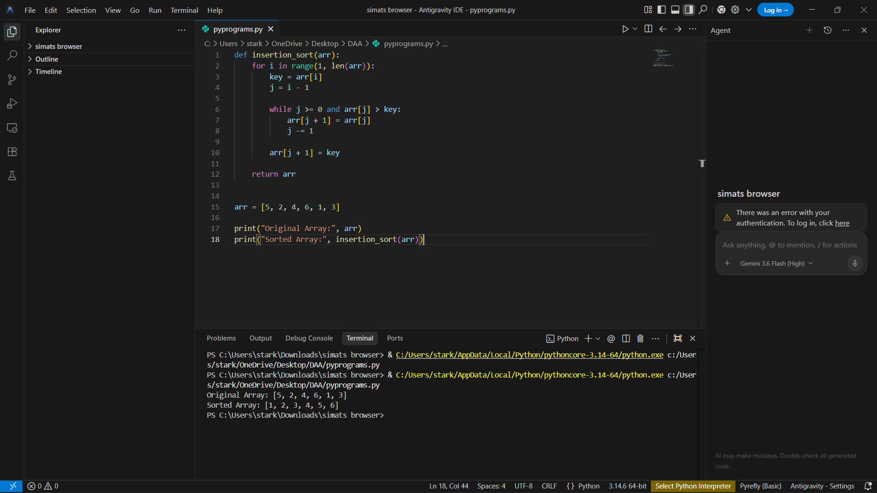

Why Incorrect Insertion Occurs
The algorithm shifts elements correctly but inserts the key at the wrong index (arr[j] instead of arr[j + 1]). Additionally, the condition j > 0 prevents the first element from being compared, causing the smallest element to remain unsorted. As a result, elements may be overwritten, duplicated, or placed in the wrong position.
Time Complexity
- Best Case: O(n)
- Average Case: O(n²)
- Worst Case: O(n²)
- Space Complexity: O(1)

